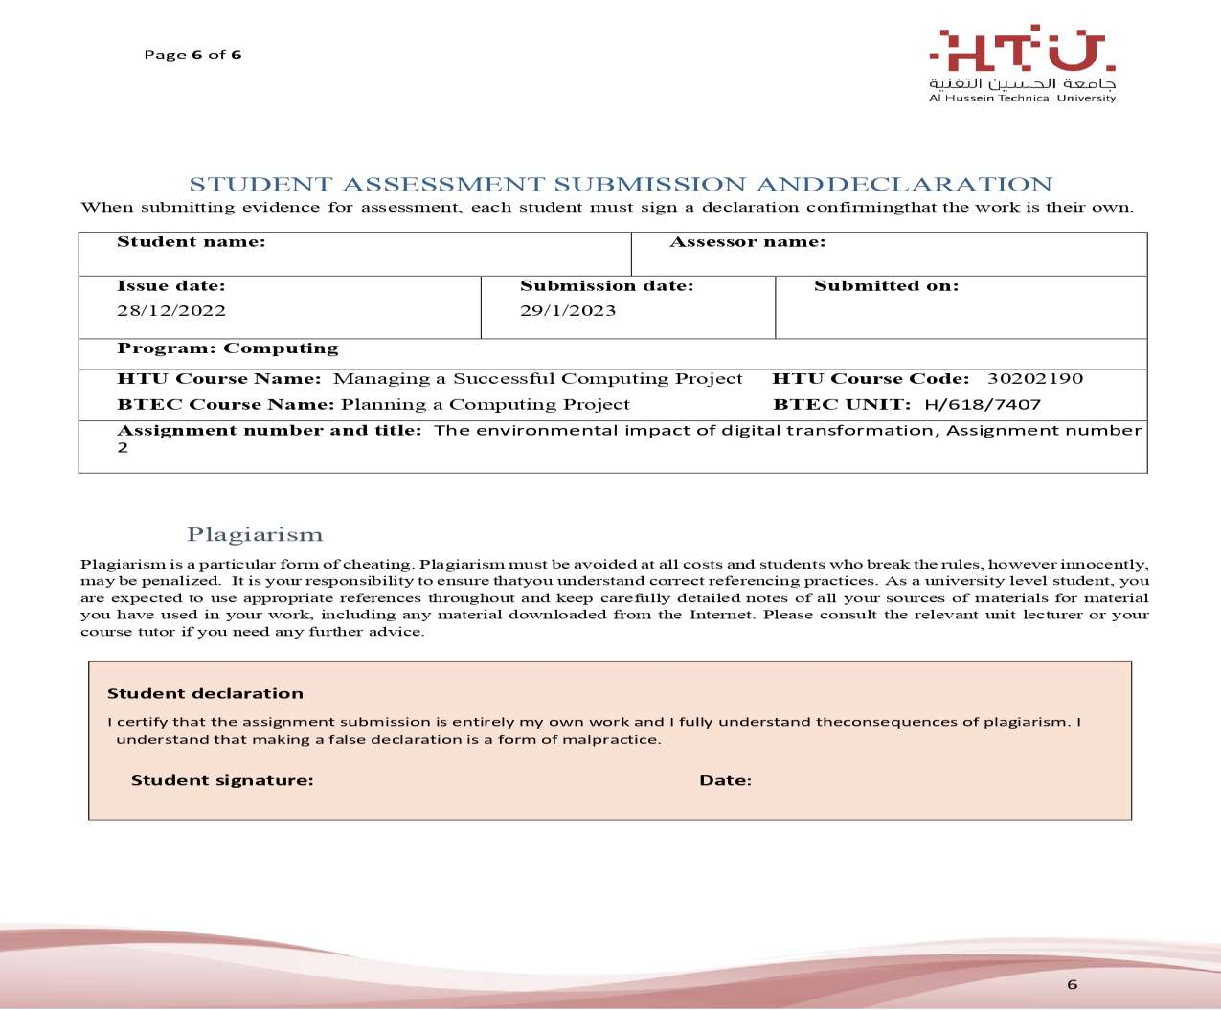

29/1/2023

Saif haddad

Dania alsaid

29/1/2023

Saif haddad